English

Cantonese

Mandarin



LANGUAGES



Intern - Auditing

Served one of the largest China-invested property management company based in Hong Kong.

Associate - Auditing (Consumer Business and Manufacturing)

Served one of the largest listed chemical manufacturers in China, a listed IT-related company in Hong Kong and a trading company with international operations.

Completed company-level audits with minimal coaching, and assisted senior auditors in consolidation-level audits.

Worked in China and overseas countries, including the United States. Familiar with accounting standards among diﬀerent regions. Able to communicate ﬂuently with clients in diﬀerent countries.

Deloitte Touche Tohmatsu

**JAN 2012 – APR 2012**

Audit   
Research   
Data Analytics   
Writing Leadership

Communication

Team Player



(852) 6224 0349

[jason.tamkh@gmail.com](mailto:jason.tamkh@gmail.com)

linkedin.com/in/jason-tamkh

KEY SKILLS

PricewaterhouseCoopers

Senior Associate - Auditing (Financial Service)

Served one of the largest banks in China (40% of time), components of a Hong Kong government authority (40% of time), and several assets management clients.  
Performed audit for a client with PE and RE fund investments and several direct equity and RE investments, in which was required to examine the partnership agreements and investment structure, and review the fair value models of those investments.

Analysed the performance of my clients by use of relevant market data, including offshore and onshore currency and interest rates, peers’ benchmarks and security market index.

Handled treasury cycle of a banking industry client, was familiar with different derivatives such as currency swap and interest rate swap.

Demonstrated excellent project management skill by managing work allocation, audit timeline and junior staﬀ coaching. Maintained good collaboration with diﬀerent service teams, including Valuation Advisory team and Tax team, to facilitate audit work.

EDUCATION BACKGROUND

The Chinese University of Hong Kong (CUHK)

Major in Professional Accountancy

Second Class Upper Honour

Course highlight: Financial Reporting, Business Management, Corporate Governance, Business and Company Law

**SEP 2010 – JUN 2014**

PLK Vicwood K.T. Chong Sixth Form College

**SEP 2008 – JUN 2010**

3As in HKALE (including Pure Mathematics and Applied Mathematics)

CFA Level II Candidate

PROFESSIONAL QUALIFICATION

WORK EXPERIENCE

**DEC 2015 – PRESENT**

Completed HKICPA QP Examinations

Deloitte Touche Tohmatsu

**SEP 2014 – DEC 2015**

Independent auditor experienced in performing external audits for business clients in retail, manufacturing and ﬁnancial service sectors. Developed solid research and analytical skills through performance of business review. Managed to understand clients’ internal controls and provide advice to reduce ﬁnancial and operational risk. Demonstrated strong leadership with engagement management and staff coaching.

PROFESSIONAL PROFILE

CONTACT

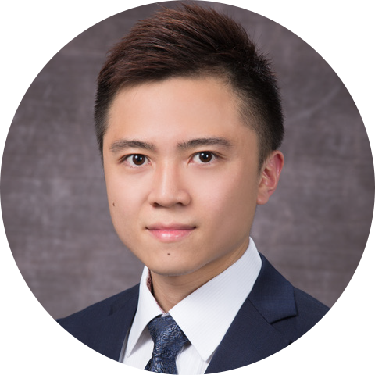

**TAM KA HO, JASON**